SIMATS ENGINEERING (SAVEETHA SCHOOL OF ENGINEERING)
Department of Artificial Intelligence and Data Science
ASSESSMENT TOOL 1 – APPLICATION BASED QUESTIONS

Course Code: | DSA03 | Course Title: | Natural Language Processing
CO Assessed: | CO1 – Imitation (L1) | Assessment: | Assessment Tool 1 – Application Based Questions
Weightage: | 40% of CIA
CO1 Statement: | Analyse NLP models, regular expression patterns, finite state automata, morphological processing techniques and to interpret language processing. (BL-3)
Student Name: | S BALA VIJAY | Reg. No.: | 192424160
Section / Batch: | AIDS | Date: | 07-10-2026

Code of Conduct
I S BALA VIJAY / 192424160 certify that this submission is my original work and that I have adhered to the guidelines specified for this assessment. I understand that any violation of academic integrity rules will result in disciplinary action.
Signature of the Student: S BALA VIJAY

Instructions
- Develop a modular and efficient Python program that satisfies all the functional requirements specified in the problem statement.
- Demonstrate the correctness of the implementation using suitable test cases and justify the output obtained.
- Follow good programming practices, including meaningful variable names, proper code indentation, comments, and error handling wherever applicable.
- Duration: 30 minutes.

Section / Topic | Focus | Q Nos
Information Extraction | Regex-Based Information Extraction | 1
Pattern Matching | Regex Pattern Matching | 2
Regular Expression Patterns | Regex-Based Input Validation | 3

Annexure A – Application Based Questions

Section 1: Regular Expressions – Resume Information Extraction
- A multinational recruitment company receives thousands of resumes every day in text format. The HR department requires an automated system to extract candidate information for shortlisting.

Design and implement a Python-based resume information extraction system using Regular Expressions that performs the following tasks:

Extract the candidate's name.
Identify email addresses.
Extract mobile numbers.
Detect technical skills (Python, Java, SQL, Machine Learning, NLP).
Extract years of experience.
Generate a structured summary of the candidate's profile.
Display candidates who satisfy the minimum eligibility criteria (minimum 2 years of experience and Python skill).
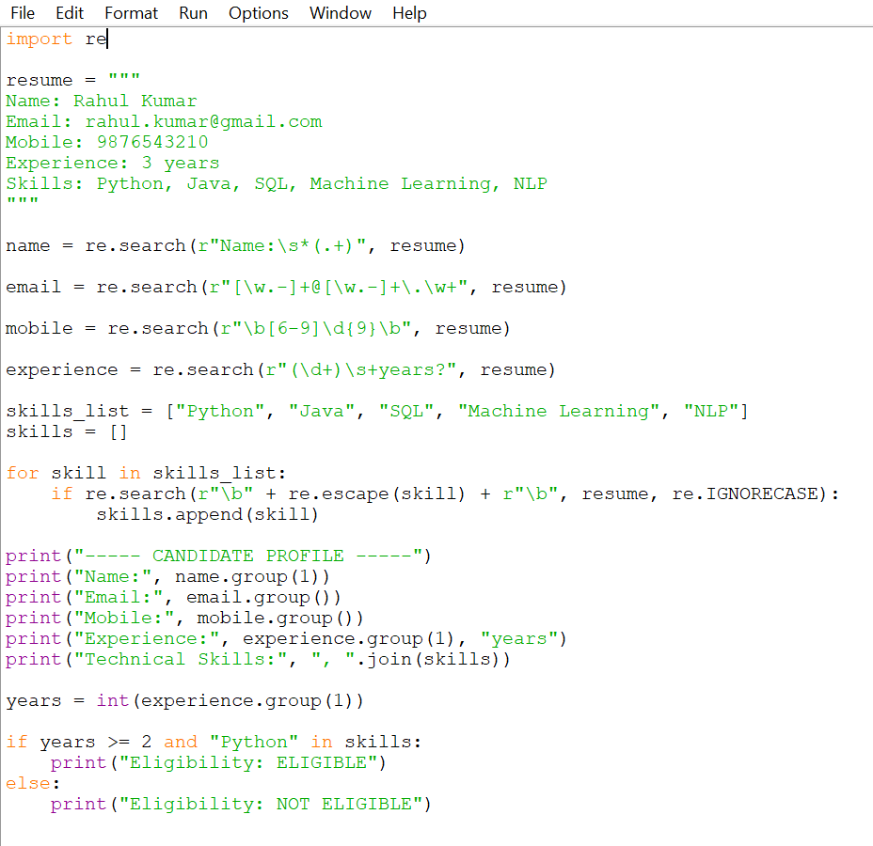
Output:
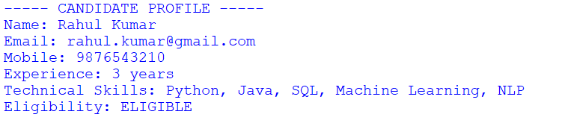
Section 2: Regular Expressions – Product Search System
- An e-commerce company plans to enhance its product search engine to improve customer experience through flexible keyword matching.

Design and implement a Python-based product search system using Regular Expressions that performs the following tasks:

Search products using an exact keyword.
Perform prefix-based searches.
Perform suffix-based searches.
Search using partial keywords.
Perform case-insensitive searches.
Display all matching product names.
Generate a report showing the total number of matching products for each search.
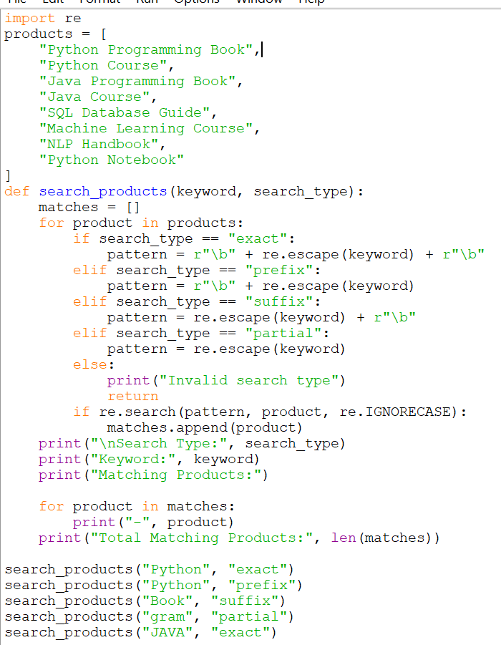

Output :
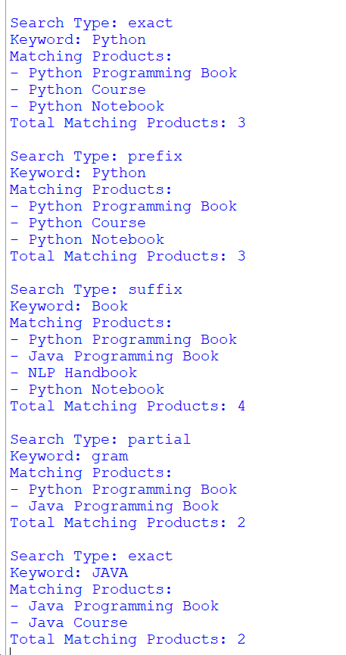

Section 3: Regular Expressions – University Registration System
A university is developing an automated online registration portal to verify student information before course enrollment.

Design and implement a Python-based validation system using Regular Expressions that performs the following tasks:

Validate the student register number.
Validate the institutional email address.
Validate the course code.
Validate the semester information.
Validate the student's mobile number.
Display appropriate validation messages for each field.
Generate a final registration status report indicating whether the registration is successful.
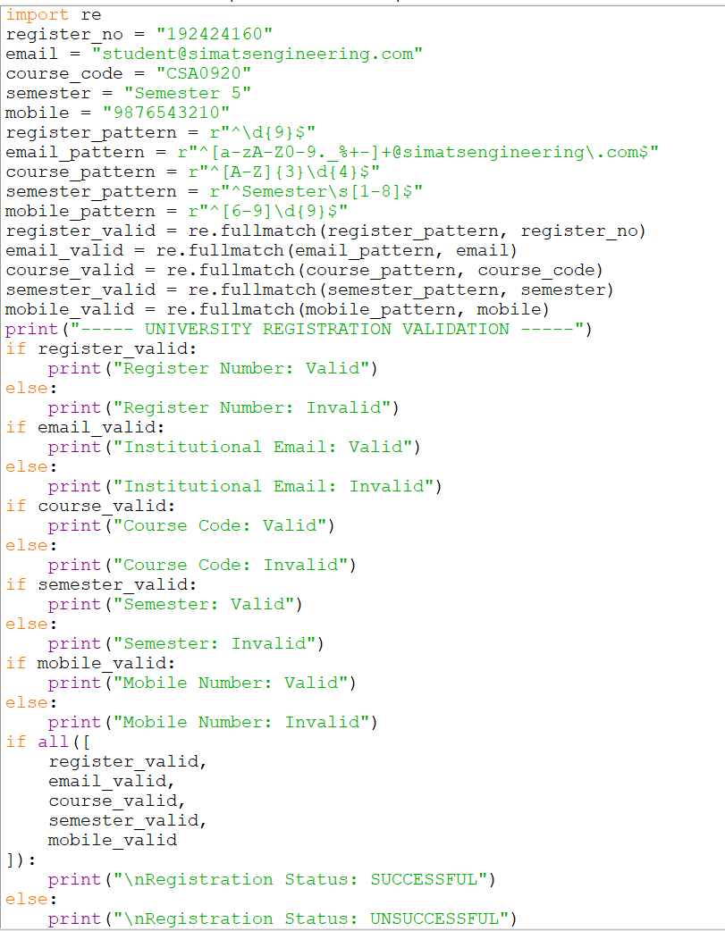
Output:
